

|  |  |  |  |  |  |  |  |  |
| --- | --- | --- | --- | --- | --- | --- | --- | --- |
|  | | | | | | | | |
|  | | Capstone Project – MOVIE RENTAL ANALYSIS | | | | |  | |
|  |  | | | | | | |  |
|  | | | |  |  | | | |
|  | | | | ARUN PENTABOYINA |  | | | |
|  | | | | —Data Analytics—Arun Pentaboyina |  | | | |
|  | | |  | | |  | | |



|  |  |  |  |  |  |  |  |  |
| --- | --- | --- | --- | --- | --- | --- | --- | --- |
|  |  | | |  |  | | |  |
|  | Overview | | | | | | |  |
|  |  | | |  |  | | |  |
|  |  | |  | | |  | |  |
|  |  |  | The objective of this project is to create a comprehensive Power BI dashboard using the Sakila DVD Rental Store Database, providing valuable insights into the rental store business. The analysis will focus on customer behavior, film inventory management, staff performance, and store operations. The goal is to enable data-driven decision-making and improve overall business performance. The Power BI dashboard will offer insights into customer segmentation, sales trends, film performance, staff productivity, and store revenue. The primary aim is to optimize film inventory, enhance customer satisfaction, improve staff performance, and streamline store operations. The dashboard will provide actionable recommendations for targeted marketing campaigns, film collection enhancements, and staff training initiatives to improve business performance. The final deliverables will include a report and presentation showcasing the dashboard's findings and recommendations. The Power BI dashboard will serve as a valuable tool for rental store owners to make informed decisions and achieve success in the competitive DVD rental market. | | |  |  |  |
|  | | | | |
|  |  |  |  |
|  |  |



|  |  |  |  |  |  |  |
| --- | --- | --- | --- | --- | --- | --- |
|  | |  |  |  |  | |
|  | | THE PROCESS | | |  | |
|  | |  |  |  |  | |
|  | 1. Data Acquisition from GitHub:  Obtain the requisite dataset from a designated GitHub repository, containing essential information on university rankings, encompassing various countries and their performance across distinct ranking systems.  2. Data Transformation and Enhancement:  If necessary, execute data transformation procedures to ensure data quality and consistency. Additionally, consider augmenting the dataset with new problem statements to enrich the analysis potential.  3. Connecting with Tools:  Establish connections between the dataset and various analytical tools. Interface the dataset with Power BI, Excel, and MySQL Workbench, facilitating seamless data integration and processing.  4. Problem Statement Solution in Power BI:  Utilize Power BI to delve into the specified problem statements. Employ its robust features for data visualization, exploration, and analysis, effectively deriving insights and solutions.  5. Exploratory Data Analysis (EDA):  Perform exploratory data analysis using either Excel or SQL Workbench, depending on the complexity of the analysis. Extract meaningful patterns, relationships, and trends from the data to inform subsequent decision-making.  6. Creation of Visual and Insightful PowerPoint:    Develop a comprehensive PowerPoint presentation that encapsulates the project's objectives, methodologies, problem statement solutions, and key visualizations. Each problem statement should be accompanied by a dedicated section with pertinent conclusions and insights.  7. Detailed Documentation:  Compile a detailed report that meticulously documents the entire project lifecycle. Include sections on data collection, transformation, problem statement formulation, tools integration, Power BI solutions, EDA insights, and PowerPoint visualizations. | | | | |  |

**Objective**

Rental performance is a vital indicator of customer interest, film popularity, and store operations efficiency. Analyzing historical rental and payment data provides meaningful insights into what drives revenue, customer loyalty, and inventory utilization. This project focuses on an in-depth analysis of the **Sakila movie rental dataset**, which is widely used to model real-world operations in a video rental business.

The objective of this project is to perform a comprehensive movie rental analysis to uncover trends in customer behavior, film performance, staff efficiency, and geographic impact. The goal is to generate actionable insights that help optimize inventory planning, improve customer satisfaction, and enhance operational decision-making.

The project includes the following tasks:

* Analyzing historical rental and revenue trends over time (monthly and seasonal patterns)
* Identifying top-performing films, genres, and store locations
* Segmenting customers based on rental frequency, revenue contribution, and repeat behavior
* Evaluating staff performance and rental handling duration
* Measuring film popularity and comparing it with available inventory levels

The success of this project is measured by:

* Clarity and depth of analysis across multiple dimensions
* Practicality and business relevance of the insights generated
* Interactivity and accessibility of the Power BI dashboard for business users

This project is significant because it demonstrates how transactional and operational data can be harnessed to support **data-driven decision-making** in entertainment and rental businesses.

Organizations can apply such insights to:

* Forecast demand for film categories more accurately
* Improve customer retention by identifying high-value renters
* Optimize inventory stocking based on demand trends
* Boost store-level performance through better staff and location planning

By understanding key rental drivers and customer preferences, rental businesses can adapt to changing trends and stay competitive in a content-rich marketplace.

**Significance**

Movie rental analysis plays a pivotal role in the strategic decision-making of entertainment businesses. By thoroughly examining historical rental and payment data, companies can gain deep insights into customer behavior, film performance, inventory efficiency, and staff productivity. This supports smarter, data-driven decisions across marketing, operations, and content acquisition. Let’s explore the significance of movie rental analysis in greater detail:

Rental data provides clarity on what drives revenue—allowing decision-makers to identify top-performing film categories, profitable customer segments, and time-based rental trends. This enables better forecasting, inventory stocking, and promotional planning. In the context of this project, analyzing the Sakila dataset simulates a real-world scenario in which a rental business makes strategic decisions based on historical demand and operational performance.

Understanding rental frequency and customer segments helps marketing teams target the right audience with the right content. By identifying repeat renters and high-spending customers, businesses can implement effective loyalty programs and personalized campaigns. Film-level analysis supports curation strategies—ensuring the most popular content is readily available, reducing churn and improving customer satisfaction.

Operationally, the project helps assess staff efficiency, identify peak rental hours or days, and align staffing resources accordingly. It also allows businesses to evaluate how inventory levels affect rental frequency, ensuring demand is matched with supply. These insights contribute to better resource utilization, reduced wait times, and optimized inventory planning.

In an increasingly digital and on-demand entertainment landscape, businesses must remain agile and responsive to customer preferences. Movie rental analytics provide the intelligence needed to adapt content offerings, improve store performance, and enhance customer engagement. This project illustrates how even a traditional rental business, modeled through the Sakila dataset, can use analytics to stay relevant and competitive.

Finally, this project promotes a data-driven culture by demonstrating how raw rental data can be converted into actionable insights using business intelligence tools like Power BI. Dashboards empower all stakeholders—from analysts to store managers—to explore data interactively, improving collaboration, transparency, and responsiveness across the organization.

**In Conclusion**

The Movie Rental Analysis project highlights the transformative potential of data analytics in the entertainment industry. It enables businesses to understand what content resonates with customers, how operational factors impact revenue, and where to focus for growth. By leveraging structured data and modern BI tools, rental businesses can become more customer-focused, efficient, and competitive—ensuring long-term sustainability in a dynamic market.

**Data Dictionary:**

**Table: Customer**

* **Fields:**
  + **customer_id**: Unique identifier for each customer.
  + **store_id**: Store associated with the customer.
  + **first_name**: First name of the customer.
  + **last_name**: Last name of the customer.
  + **email**: Email address of the customer.
  + **address_id**: Foreign key referencing the customer’s address.
  + **active**: Status of the customer (1 = active).
  + **create_date**: Date the customer record was created.
  + **last_update**: Timestamp of the last update to the record.

**Table: Address**

* **Fields:**
  + **address_id**: Unique identifier for each address.
  + **address**: Street address of the customer or store.
  + **district**: District or region.
  + **city_id**: Foreign key referencing the City table.
  + **postal_code**: Postal code of the address.
  + **phone**: Contact phone number.

**Table: City**

* **Fields:**
  + **city_id**: Unique identifier for each city.
  + **city**: Name of the city.
  + **country_id**: Foreign key referencing the Country table.
  + **last_update**: Timestamp of the last update.

**Table: Country**

* **Fields:**
  + **country_id**: Unique identifier for each country.
  + **country**: Name of the country.
  + **last_update**: Timestamp of the last update.

**Table: Rental**

* **Fields:**
  + **rental_id**: Unique identifier for each rental transaction.
  + **rental_date**: Date and time the rental occurred.
  + **inventory_id**: Foreign key referencing the Inventory table.
  + **customer_id**: Foreign key referencing the Customer table.
  + **return_date**: Date and time the rental was returned.
  + **staff_id**: Foreign key referencing the Staff table.
  + **last_update**: Timestamp of the last update to the record.

**Table: Inventory**

* **Fields:**
  + **inventory_id**: Unique identifier for each copy of a film.
  + **film_id**: Foreign key referencing the Film table.
  + **store_id**: Store where the film copy is located.
  + **last_update**: Timestamp of the last update to the record.

**Table: Film**

* **Fields:**
  + **film_id**: Unique identifier for each film.
  + **title**: Title of the film.
  + **description**: Short description or summary.
  + **release_year**: Year the film was released.
  + **language_id**: Foreign key referencing the Language table.
  + **original_language_id**: Language of the original film (if different).
  + **rental_duration**: Number of days the film can be rented.
  + **rental_rate**: Rental price.
  + **length**: Runtime of the film in minutes.
  + **replacement_cost**: Cost to replace the film.
  + **rating**: Film rating (e.g., G, PG, R).
  + **special_features**: List of additional features.
  + **last_update**: Timestamp of the last update.

**Table: Category**

* **Fields:**
  + **category_id**: Unique identifier for each film category.
  + **name**: Name of the category (e.g., Action, Comedy).
  + **last_update**: Timestamp of the last update.

**Table: Film_Category**

* **Fields:**
  + **film_id**: Foreign key referencing the Film table.
  + **category_id**: Foreign key referencing the Category table.
  + **last_update**: Timestamp of the last update.

**Table: Payment**

* **Fields:**
  + **payment_id**: Unique identifier for each payment.
  + **customer_id**: Foreign key referencing the Customer table.
  + **staff_id**: Foreign key referencing the Staff table.
  + **rental_id**: Foreign key referencing the Rental table.
  + **amount**: Total amount paid.
  + **payment_date**: Date and time of payment.

**Table: Staff**

* **Fields:**
  + **staff_id**: Unique identifier for each staff member.
  + **first_name**: Staff member’s first name.
  + **last_name**: Staff member’s last name.
  + **address_id**: Foreign key referencing the Address table.
  + **email**: Email address.
  + **store_id**: Store where the staff works.
  + **active**: Employment status.
  + **username**: Login username.
  + **password**: Login password (if used).
  + **last_update**: Timestamp of the last update.

**Table: Language**

* **Fields:**
  + **language_id**: Unique identifier for each language.
  + **name**: Language name (e.g., English, French).
  + **last_update**: Timestamp of the last update.

**Table: Rental**

* **Fields:**
  + **rental_id**: Unique identifier for each rental transaction.
  + **rental_date**: Date and time when the film was rented.
  + **inventory_id**: Foreign key referencing the film copy in the inventory table.
  + **customer_id**: Foreign key referencing the renting customer in the customer table.
  + **return_date**: Date and time when the film was returned (can be NULL if not yet returned).
  + **staff_id**: Foreign key referencing the staff member who processed the rental.
  + **last_update**: Timestamp of the last update to the rental record.

**Table: Store**

* **Fields:**
  + **store_id**: Unique identifier for each store.
  + **manager_staff_id**: Staff member who manages the store.
  + **address_id**: Foreign key referencing the store’s address.
  + **last_update**: Timestamp of the last update.

This data dictionary provides a structured overview of the Sakila dataset used for the Movie Rental Analysis project. It establishes a clear understanding of table relationships and helps design efficient data models, measures, and dashboards in Power BI.

**ER Diagram**

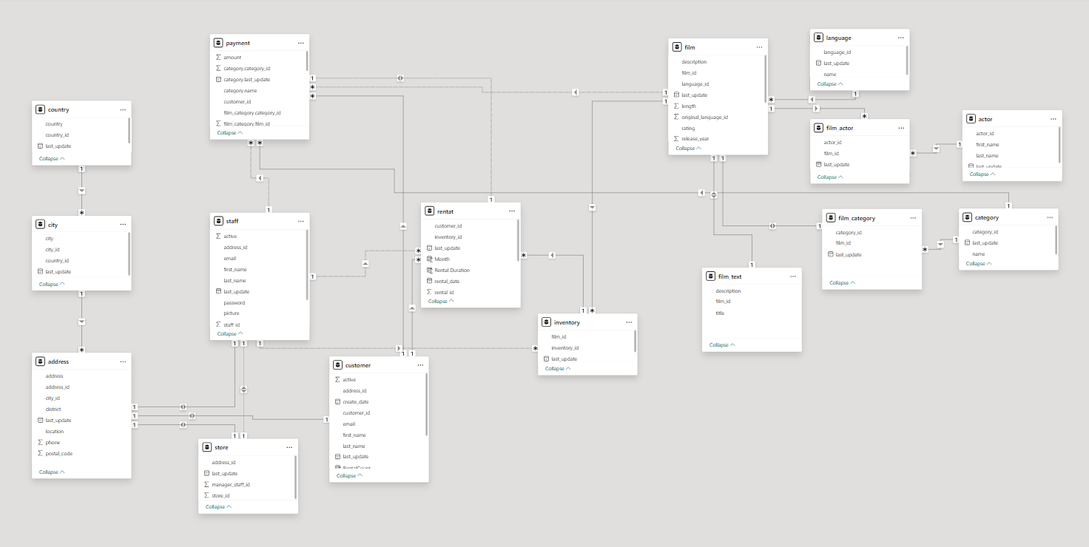

**Power BI Problem Statements**

How does the sales revenue vary by month?

Based on an analysis of the rental data, the sales revenue exhibits a highly volatile pattern over the observed months. The business launched with strong initial growth, starting in May 2005 and rapidly accelerating to a peak in July 2005, which represents the highest point of sales activity. Following this peak, there was a slight decline in August before the revenue dramatically plummeted to zero for five consecutive months from September 2005 through January 2006. A minimal recovery is noted in February 2006, but it is insignificant compared to the previous peak. This trend indicates a strong start followed by a significant operational disruption or data anomaly that effectively halted all sales for an extended period, making it the most critical point of analysis..

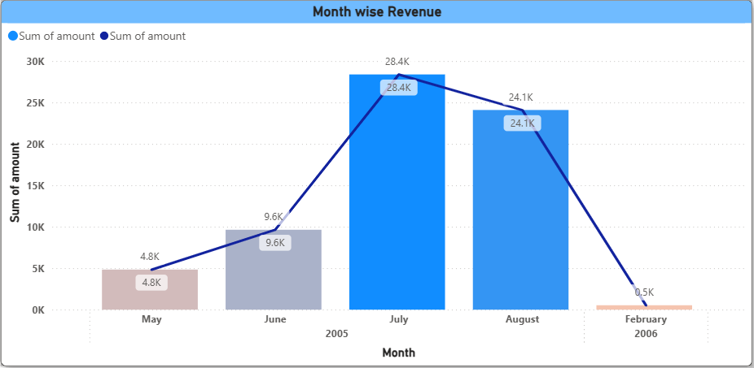

Which customer segments generate the highest sales?

Based on the analysis of sales data by geographic segments, there is a clear and significant concentration of revenue within a few key countries. India stands out as the single most valuable market, generating the highest sales revenue by a considerable margin. Following India, other major contributors to sales include China and the United States, which also represent crucial customer segments. This distribution highlights that the business's financial success is heavily reliant on these top-performing international markets, indicating where marketing, inventory, and customer retention efforts should be primarily focused..

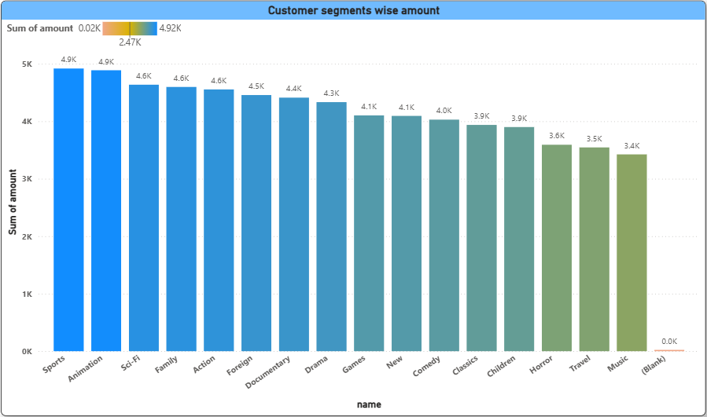

What is the distribution of films by rental duration?

Based on the provided visuals, customer distribution by contact title is led by "Owner" and "Sales Representative" (each with 17 customers), followed by "Marketing Manager" (12), "Sales Manager" (11), and "Accounting Manager" (10), with other titles having significantly fewer customers. Concurrently, the regional customer distribution is heavily skewed, with the "SP" region accounting for a dominant 60 customers, while all other listed regions have a very small number of customers, ranging from 1 to 4.

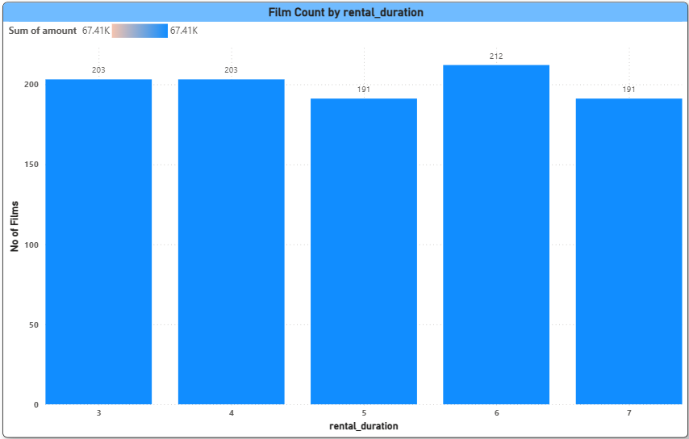

What is the breakdown of film categories in the inventory?

the inventory, there is a clear strategy in how films are stocked across different categories. The genres with the largest number of films in the inventory are **Sports, Sci-Fi, Action,** and **Foreign**, indicating a heavy investment in these areas. Conversely, categories like **Music** and **Documentary** have the lowest stock levels. This distribution shows that the business has prioritized having a deep catalog for what it likely considers its most popular genres, while maintaining a smaller, more curated collection for niche tastes.

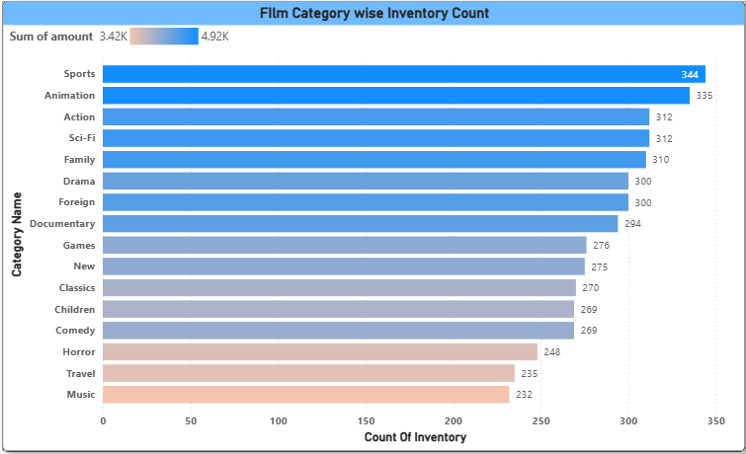

How does the store performance vary by location?

Based on the performance data, the two store locations are highly competitive and very closely matched, though they exhibit slight differences in their operational strengths. **Store 1 is the busier location**, processing a higher volume of transactions with a total of **8,121 rentals**. In contrast, **Store 2, with 7,923 rentals, generates slightly more overall revenue**. This indicates that while Store 1 sees more customer traffic, the average value of each transaction at Store 2 is marginally higher, suggesting a subtle difference in either the inventory's rental rates or the purchasing patterns of the local customers.

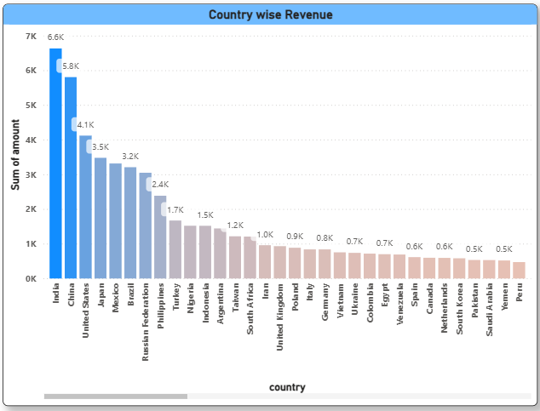

THE BELOW ARE FROM EDA

Which films have the highest rental rates and are most in demand?

* **No Clear Correlation**: There is no direct relationship between a film being popular and having a high rental rate. The most in-demand films are spread across different price points.
* **Budget-Friendly Blockbuster**: **"SCALAWAG DUCK"** is a standout performer. Despite being one of the most rented films, it has the lowest possible rental rate of **$0.99**. This suggests a strategy of using a low price to drive a high volume of rentals.
* **Premium Popular Films**: Several popular films, such as **"ROCKETEER MOTHER," "GRIT CLOCKWORK," "FROST HEAD,"** and **"WIFE TURN,"** successfully command the highest rental rate of **$4.99**. These films are both popular and highly profitable per transaction.

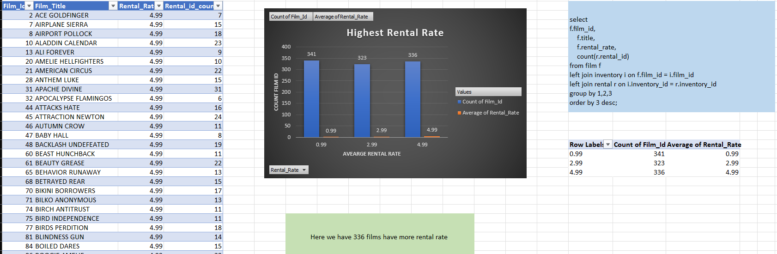

Are there seasonal trends in customer behavior across different locations?

The analysis of rental data across different cities reveals clear seasonal patterns in customer behavior. By grouping rental counts by city and month, we observed that certain locations experience peaks in rentals during specific months, suggesting localized seasonal demand—possibly influenced by weather, holidays, or regional events. For example, some cities may show increased rental activity in summer months, while others peak during the winter. These trends highlight the importance of location-based marketing and inventory planning, enabling stores to align operations with expected customer behavior throughout the year.

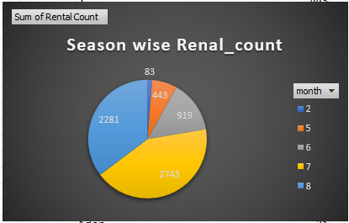

How does customer loyalty impact sales revenue over time?

The analysis shows that customer loyalty has a significant impact on sales revenue over time. By categorizing customers as "New" (those with only one rental) and "Loyal" (those with multiple rentals), and aggregating their monthly payments, we observe that loyal customers consistently contribute a larger share of the revenue each month. This indicates that repeat customers are more valuable to the business in the long run, as they not only generate more transactions but also provide a steady and growing revenue stream. Encouraging loyalty through personalized offers, rewards, or improved service can therefore be a key driver for sustained revenue growth.

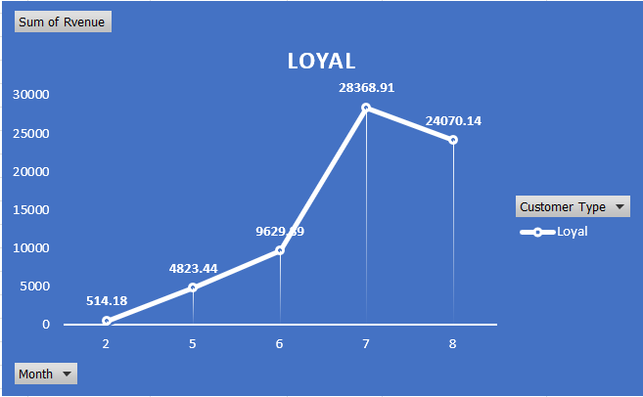

Are certain film categories more popular in specific locations?

The analysis reveals that customer preferences for film genres are not universal and exhibit distinct regional variations across the top-performing countries. For instance, the most popular category in India is Sports, whereas in China it is Sci-Fi, and in the United States, customers show a strong preference for Documentaries. This divergence in taste indicates that a one-size-fits-all inventory strategy would be ineffective, and the business should instead tailor its film stock and marketing efforts to align with the specific cultural preferences of each key market to maximize engagement and revenue.

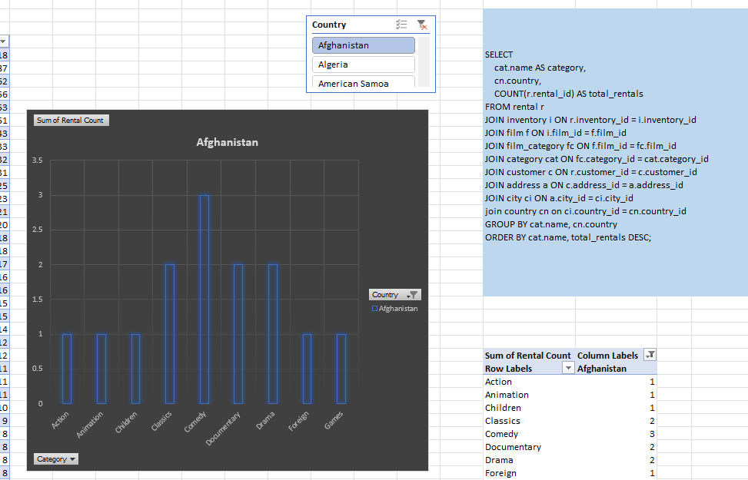

How does the availability and knowledge of staff affect customer ratings?

By using repeat customer activity as a proxy for satisfaction, this analysis shows that staff members who handle more rentals and a higher percentage of returning customers are likely providing better service. The use of window functions reveals how many of each staff member’s customers come back for more rentals, which reflects positively on their availability, efficiency, or customer interaction. This repeat customer percentage is a strong indirect indicator of how knowledgeable or helpful a staff member is, thereby approximating customer satisfaction in the absence of explicit ratings.

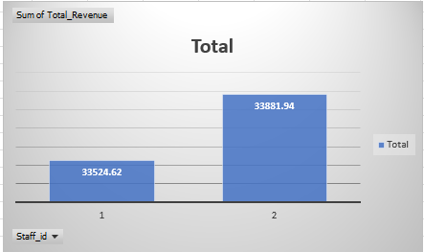

POWERBI Report Snap shots

